Hello,

We need the following changes implemented:

1. We need the index collum (that it is present in the Entry-exit register form)
   1. 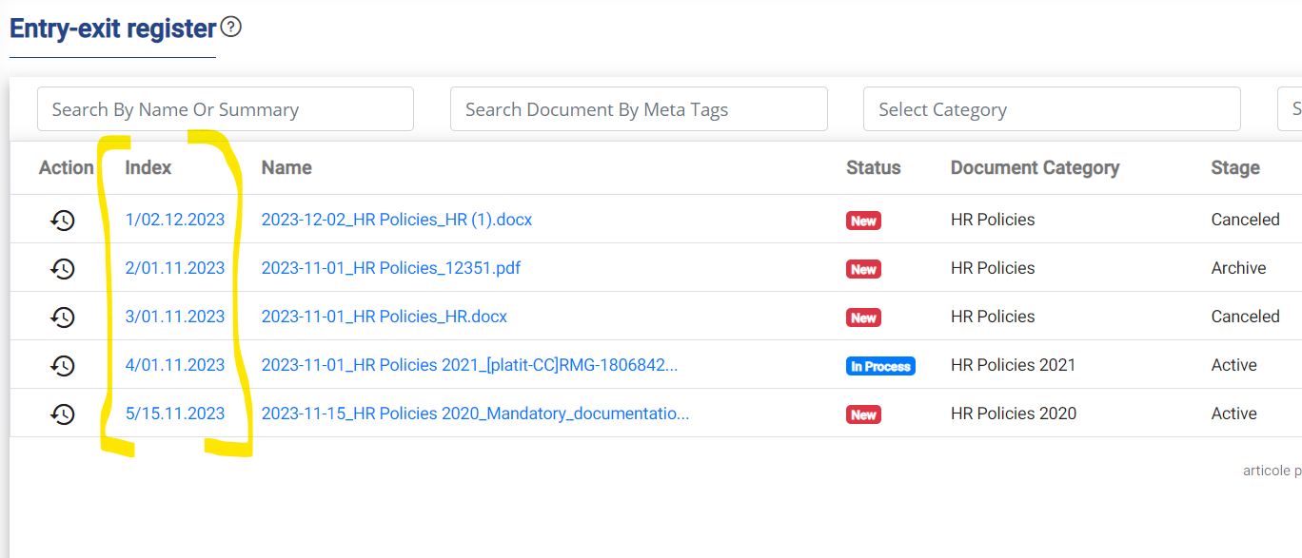
   2. To be added in the Assigned Documents and All Documents forms between Action and Name collum(s).
   3. 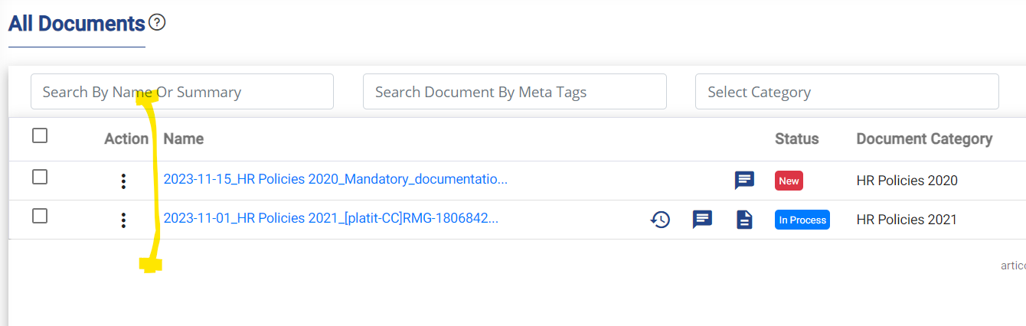
   4. Also the Index label is ok in English but in Romanian should be **Nr. Înrg.**
2. When adding a new document we need to implement a tooltip that will show the name of the category followed by the description. The client wants to add a longer description to each category (subcategory) and the tooltip will indicate to the users the purpose and usage of that selected category.
   1. 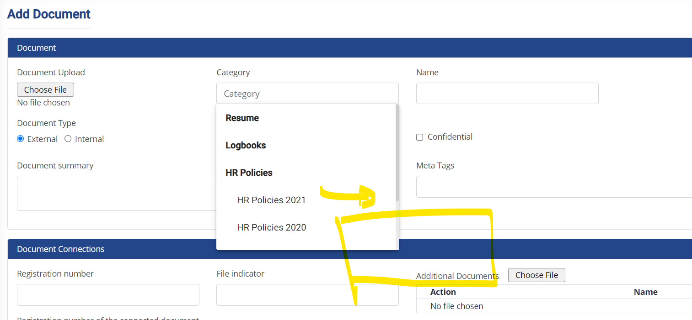
3. When a document is Cancelled, the users will be prompted the Are you sure you want to Cancel … message – which is fine and need to add a second dialog that will ask for reason of cancellation. The English text will be “Reason for cancellation”, Romanian will be “Motivul anulării” and a text area below (that will be stored in the table associated with the document Remarks) and Ok button. I am thinking to store it in the Remarks in order to avoid an additional field just for this processing.
4. If the client has more users (like 20) the users form needs to have implemented a sorting mechanism for the table headlines. This can be implemented for all the tables where this feature is missing (if any other is missing it).
5. For additional documents we need to implement preview (open in new window) by adding the eye icon before download option.
   1. 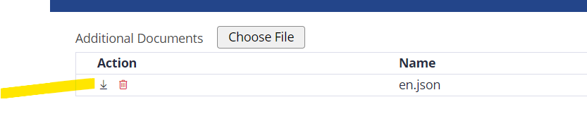
6. For the Documents Audit Trail we need to implement an excel export feature of the results like in he Entry-exit register report. Also Clear button is Romanian is not clar – it is Resetare.
   1. 
7. We need to find a solution to preview Excel documents that are uploaded. This should work for a server hosted locally. This is actually one of the reasons that they will might not accept the project and we will not be paid… So even if it seems like a minor thing it is actually pretty important.

There are some additional (but very minor) changes that I will ask for on Monday – after they will decide what it I to be done with this field.

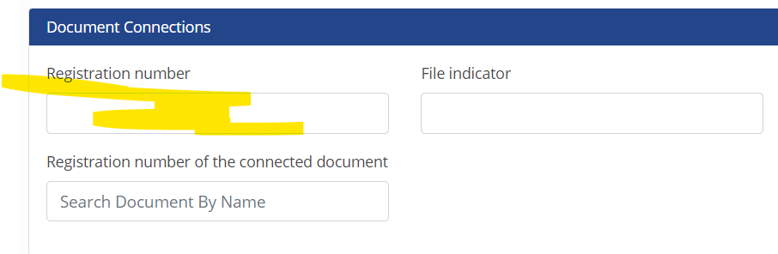

I want to provide them an updated version on 19 or 20 December.